

SCSA2602 - COMPILER DESIGN LAB

List of Experiments

- Study of LEX and YACC Tools.
- Use LEX tool to implement Lexical Analyzer (Token Separation).
- Use LEX and YACC to implement Parser. (Using Ambiguous Grammar)
- Use LEX and YACC to implement Parser (Unambiguous Grammar)
- Use LEX and YACC tool to implement Desktop Calculator.
- Construction of NFA and DFA from a regular expression.
- Implement Recursive Descent Parser algorithm.
- Implement Shift Reduce Parser algorithm.
- Implement Operator Precedence Parser algorithm.
- Implement the backend of the compiler.
- Implement Symbol Table Management.
- Construct a Simple compiler.

EX.NO.1 STUDY OF LEX TOOL

AIM: To study about lexical analyzer generator [LEX TOOL].

Introduction: The unix utility lex parses a file of characters. It uses regular expression to ‘tokenize’ the contents of the file. In that context, it is often used together with the yacc utility.

Step 1: An input file describes the lexical analyzer to be generated named lex.l is written in lex language. The lex compiler transforms lex.l to C program, in a file that is always named lex.yy.c.

Step 2: The C compiler compile lex.yy.c file into an executable file called a.out.

Step 3: The output file a.out take a stream of input characters and produce a stream of tokens.
Structure of a lex file
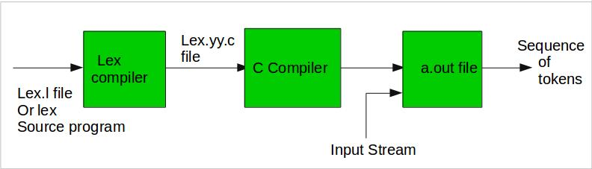

Structure of LEX Program:
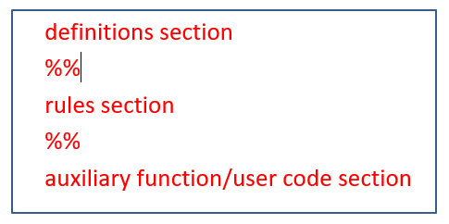

Definition Section:
  - generally used to declare functions, include header files, or define global variables and constants.
  - text is enclosed in %{ … %} brackets. Anything written in this brackets is copied directly to the file lex.yy.c
eg.:
%{
#include<stdio.h>
int global_variable;
% }
Regular definitions, has of the form,
name definition
e.g.:
digit [0-9]
letter [a-zA-Z]

Rules Section:
- Each rule has the form
pattern action
where:
  - pattern describes a pattern to be matched on the input.
  - action must begin on the same line.
  - If action is empty, the matched token is discarded.
  - eg.:
%%
{digit}+ {printf(“ number”);}
{letter}* {printf(“ name”);
%%
Sample Rules:
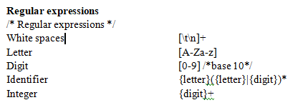
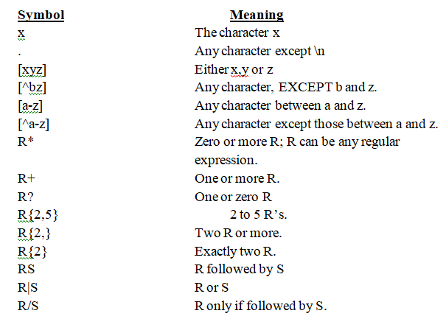
Auxiliary Functions:
LEX generates C code for the rules specified in the Rules section and places this code into a single function called yylex().
/* Declarations */
%%
/* Rules */
%%
int main()
{
yylex();
return 1;
}
- This section contain C statements and additional functions.

Lex predefined functions and variables
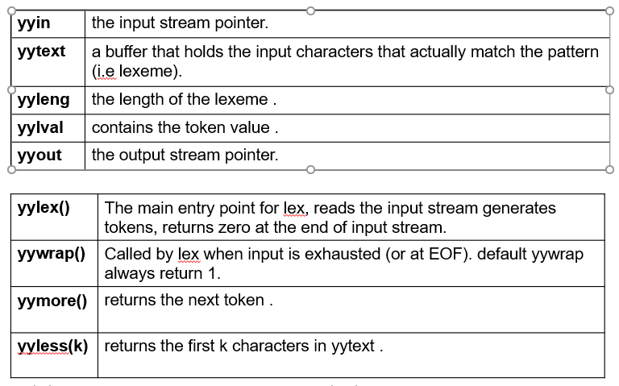
Executing a Lex Program:

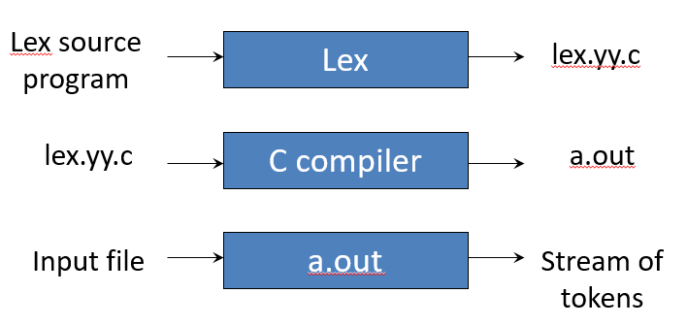

EXERCISE 2: IMPLEMENTATION OF LEXICAL ANALYZER USING LEX (Token Generation)

AIM: To perform token separation by writing patterns and actions using LEX.

ALGORITHM:

1. Declare the necessary symbols and header files needed.

2. Write the pattern and corresponding actions to be taken

2.1. if the pattern is #,* print it as a header file
2.2. if the pattern is int|float|char|return|main|… print it as a keyword
2.3. if the pattern is [“][a-zA-z][“] print it as a string
2.4. Similarly identify patterns and actions for all tokens.

3. In the main function declare a file pointer to read input file and call yylex() to find matching patterns and corresponding actions to be taken.

CODE:
%option noyywrap
%{
#include<stdio.h>
void yyerror(char *);
%}
letter [a-zA-Z]
digit [0-9]
op [-+*/]
punct [,.;"]
%%
else|if|void|int {printf("%s is a keyword",yytext);}
{digit}+ {printf("%s is a number",yytext);}
{letter}({letter}|{digit})* {printf("%s is an identifier",yytext);}
{op} {printf("%s is an operator",yytext);}
[ ] ;
\) {printf("%s is close parenthesis",yytext);}
{punct} {printf("%s is a punctuation",yytext);}
. yyerror("error");
%%
void yyerror(char *s)
{
fprintf(stderr,"%s\n",s);
}
int main(int argc, char *argv[])
{
FILE *fp;

if((fp=fopen(argv[1],"r"))==NULL)
{printf("file does not exist");}
yyin=fp;
yylex();
return 0;
}

EXERCISE 3: EVALUATION OF ARITHMETIC EXPRESSION USING YACC AND LEX(Ambiguous Grammar)

AIM: To perform parsing using YACC and LEX.
E-> E+E | E-E|E*E|E/E|(E)|ID

ALGORITHM:

- Declare the necessary header files

- Write the corresponding patterns and actions and return to yacc

- In yacc, declare the tokens and associativity of operators globally

- In the declaration part write the production rules(using ambiguous and unambiguous grammar) as patterns and prompt accept if the input matches the pattern in the action part.

- Call yyparse() in the main function to do parsing.

LEX FILE:
%option noyywrap
%{
#include<stdio.h>
#include"y.tab.h"
void yyerror(char *s);
extern int yylval;
%}
digit [0-9]
%%
{digit}+ {yylval=atoi(yytext);return NUM;}
[-+*/\n] {return *yytext;}
\( {return *yytext;}
\) {return *yytext;}
. {yyerror("syntax error");}
%%

YACC FILE:
%{
#include<stdio.h>
void yyerror(char*);
extern int yylex(void);
%}
%token NUM
%%
S:
S E '\n' {printf("%d\n",$2);}
|
;
E:
E '+' E {$$=$1+$3;}
|E '-' E {$$=$1-$3;}
|E '*' E {$$=$1*$3;}
|E '/' E {$$=$1/$3;}
|'(' E ')' {$$=$2;}
|NUM {$$=$1;}
%%
void yyerror(char *s)
{
printf("%s",s);
}
int main()
{
yyparse();
return 0;
}

EXERCISE 4: EVALUATION OF ARITHMETIC EXPRESSION USING YACC AND LEX (Unambiguous Grammar)

AIM: To perform parsing using YACC and LEX.
E-> E+T | E-T|T
T->T*F | T/F|F
F-> (E) | id

Lex Program:

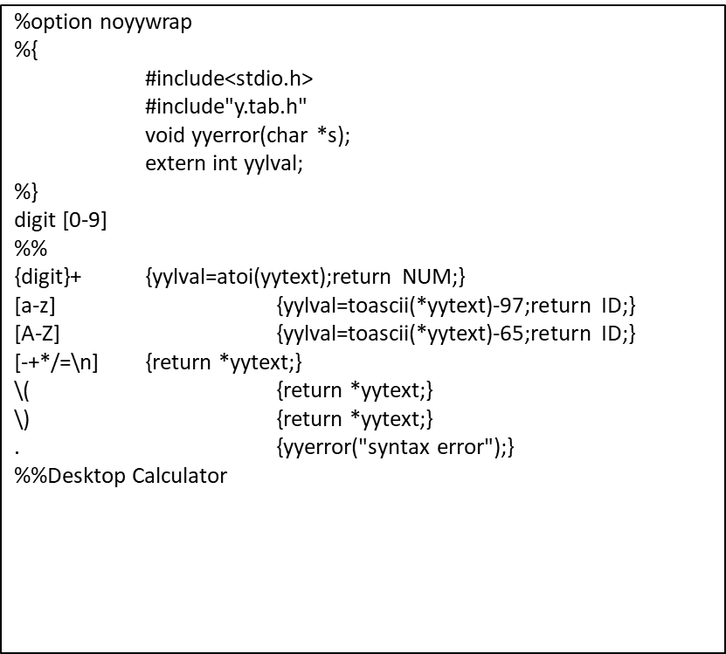

YACC Program
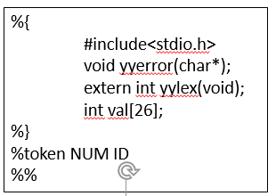
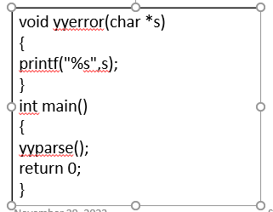
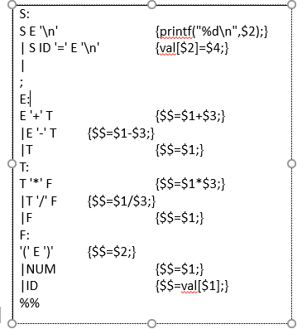

Ex.5 Desktop Calculator:

